Data structures and Algorithms
Mandatory hands-on

Ex-1: Inventory Management System
1. Why are data structures and algorithms essential in handling large inventories?
Data structures and algorithms help store, organize, search, update, and delete inventory data efficiently, improving performance and reducing execution time.
2. Types of data structures suitable for this problem?
ArrayList – Used to store a dynamic list of products.
HashMap – Used for fast searching, updating, and deleting products using Product ID.
LinkedList – Useful when frequent insertions and deletions are required.

Implementation:
Product.java:
class Product {

int productId;
String productName;
int quantity;
double price;

Product(int productId, String productName, int quantity, double price) {
this.productId = productId;
this.productName = productName;
this.quantity = quantity;
this.price = price;
}

public String toString() {
return productId + " " + productName + " " + quantity + " " + price;
}
}
InventoryManagement.java:
import java.util.HashMap;

public class InventoryManagement {

HashMap<Integer, Product> inventory = new HashMap<>();

// Add Product
public void addProduct(Product p) {
inventory.put(p.productId, p);
System.out.println("Product Added");
}

// Update Product
public void updateProduct(int id, int quantity, double price) {

Product p = inventory.get(id);

if (p != null) {
p.quantity = quantity;
p.price = price;
System.out.println("Product Updated");
} else {
System.out.println("Product Not Found");
}
}

// Delete Product
public void deleteProduct(int id) {

inventory.remove(id);
System.out.println("Product Deleted");
}

// Display Products
public void displayProducts() {

for(Product p : inventory.values()) {
System.out.println(p);
}
}

public static void main(String[] args) {

InventoryManagement obj = new InventoryManagement();

obj.addProduct(new Product(101,"Laptop",10,55000));
obj.addProduct(new Product(102,"Mouse",50,500));
obj.addProduct(new Product(103,"Keyboard",30,1200));

obj.displayProducts();

obj.updateProduct(102,60,600);

obj.deleteProduct(103);

System.out.println("\nAfter Update");

obj.displayProducts();

}
}

Output:
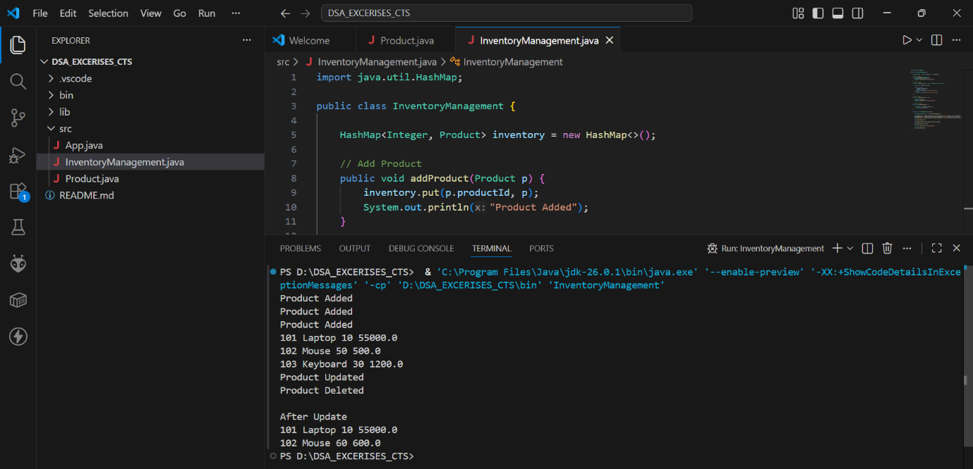

Ex-2: E-commerce Platform Search Function
1. Explain Big O notation and how it helps in analyzing algorithms.
Big O notation measures the time complexity of an algorithm and helps compare the efficiency of different algorithms as the input size increases.
2. Describe the best, average, and worst-case scenarios for search operations.
Best Case: Item is found immediately. O(1)
Average Case: Item is found after checking some elements.
Worst Case: Item is found at the end or not found. O(n) (Linear Search) / O(log n) (Binary Search)

Implementation:
SearchAlgorithms.java:
public class SearchAlgorithms {

// Linear Search
public static SearchProduct linearSearch(SearchProduct[] products, String name) {

for (SearchProduct p : products) {
if (p.productName.equalsIgnoreCase(name)) {
return p;
}
}

return null;
}

// Binary Search
public static SearchProduct binarySearch(SearchProduct[] products, String name) {

int low = 0;
int high = products.length - 1;

while (low <= high) {

int mid = (low + high) / 2;

int result = products[mid].productName.compareToIgnoreCase(name);

if (result == 0)
return products[mid];
else if (result < 0)
low = mid + 1;
else
high = mid - 1;
}

return null;
}

public static void main(String[] args) {

SearchProduct[] products = {
new SearchProduct(104, "Camera", "Electronics"),
new SearchProduct(102, "Keyboard", "Electronics"),
new SearchProduct(101, "Laptop", "Electronics"),
new SearchProduct(103, "Mouse", "Electronics")
};

SearchProduct p1 = linearSearch(products, "Mouse");

if (p1 != null)
System.out.println("Linear Search : " + p1);
else
System.out.println("Product Not Found");

SearchProduct p2 = binarySearch(products, "Mouse");

if (p2 != null)
System.out.println("Binary Search : " + p2);
else
System.out.println("Product Not Found");
}
}
SearchProduct.java:
public class SearchProduct {

int productId;
String productName;
String category;

SearchProduct(int productId, String productName, String category) {
this.productId = productId;
this.productName = productName;
this.category = category;
}

@Override
public String toString() {
return productId + " " + productName + " " + category;
}
}
Output:
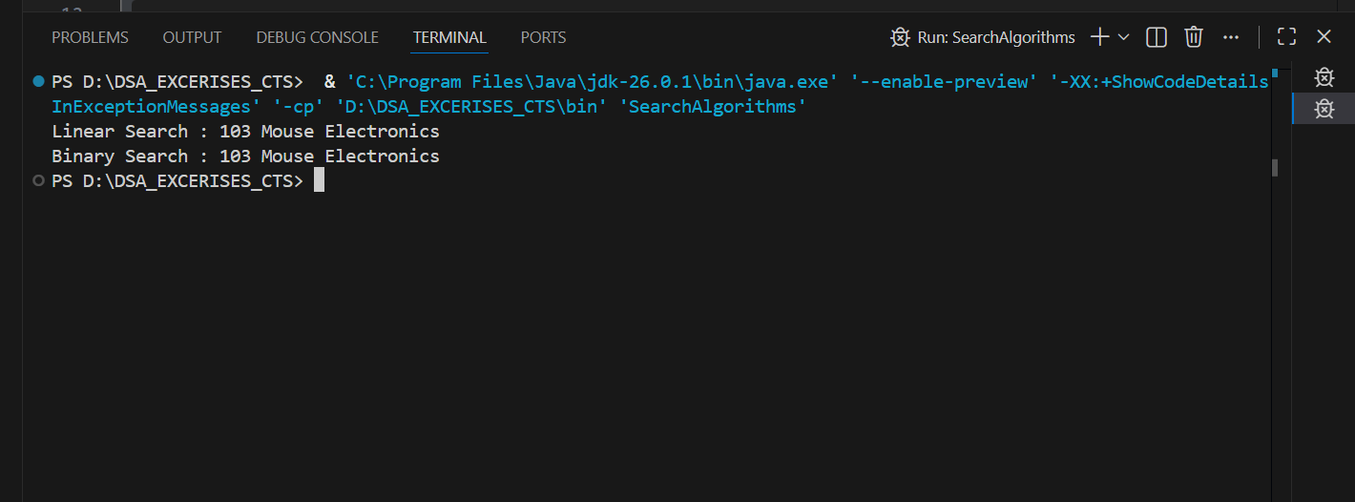

Ex-3: Sorting Customer Orders
1. Explain different sorting algorithms (Bubble Sort, Insertion Sort, Quick Sort, Merge Sort).
Bubble Sort:
Compares adjacent elements and swaps them if they are in the wrong order.
Insertion Sort:
Inserts each element into its correct position in the sorted part of the array.
Quick Sort:
Selects a pivot and partitions the array into smaller subarrays, then sorts them recursively.
Merge Sort:
Divides the array into halves, sorts each half, and merges them.

Implementation:
Order.java:
public class Order {

int orderId;
String customerName;
double totalPrice;

Order(int orderId, String customerName, double totalPrice) {
this.orderId = orderId;
this.customerName = customerName;
this.totalPrice = totalPrice;
}

@Override
public String toString() {
return orderId + " " + customerName + " " + totalPrice;
}
}

SortingOrders.java:
public class SortingOrders {

// Bubble Sort
public static void bubbleSort(Order[] orders) {

for(int i = 0; i < orders.length - 1; i++) {

for(int j = 0; j < orders.length - i - 1; j++) {

if(orders[j].totalPrice > orders[j + 1].totalPrice) {

Order temp = orders[j];
orders[j] = orders[j + 1];
orders[j + 1] = temp;
}
}
}
}

// Quick Sort
static int partition(Order[] orders, int low, int high) {

double pivot = orders[high].totalPrice;

int i = low - 1;

for(int j = low; j < high; j++) {

if(orders[j].totalPrice < pivot) {

i++;

Order temp = orders[i];
orders[i] = orders[j];
orders[j] = temp;
}
}

Order temp = orders[i + 1];
orders[i + 1] = orders[high];
orders[high] = temp;

return i + 1;
}

static void quickSort(Order[] orders, int low, int high) {

if(low < high) {

int pi = partition(orders, low, high);

quickSort(orders, low, pi - 1);
quickSort(orders, pi + 1, high);
}
}

public static void main(String[] args) {

Order[] orders = {

new Order(101,"Vinay",2500),
new Order(102,"Rahul",1500),
new Order(103,"Anjali",3500),
new Order(104,"Kiran",1000)
};

bubbleSort(orders);

System.out.println("Bubble Sort");

for(Order o : orders)
System.out.println(o);

quickSort(orders,0,orders.length-1);

System.out.println("\nQuick Sort");

for(Order o : orders)
System.out.println(o);
}
}
Output:
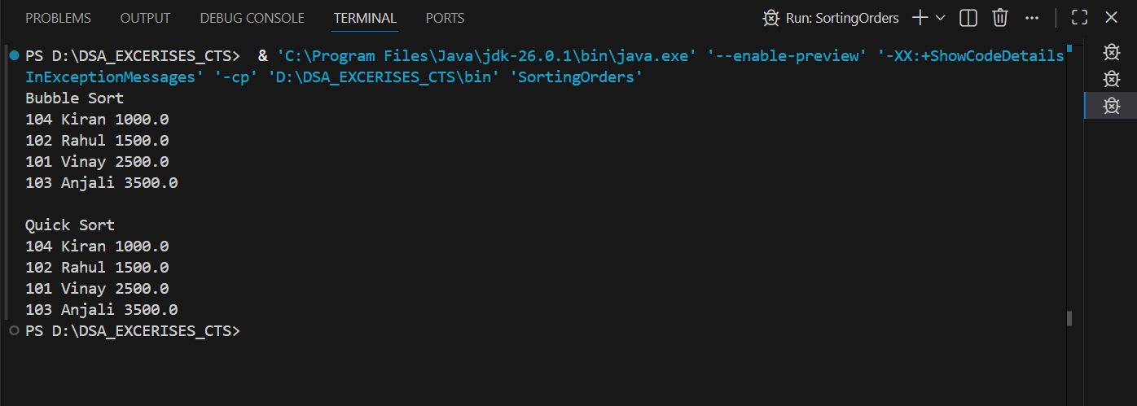

Ex-4: Employee Management System
1. Explain how arrays are represented in memory and their advantages.
Arrays store elements in contiguous memory locations, allowing fast access using an index.
Advantages of Arrays
- Fast access using index.
- Easy to traverse.
- Memory efficient.
- Suitable for storing fixed-size data.
Implementation:
Employee.java:
public class Employee {

int employeeId;
String name;
String position;
double salary;

Employee(int employeeId, String name, String position, double salary) {
this.employeeId = employeeId;
this.name = name;
this.position = position;
this.salary = salary;
}

@Override
public String toString() {
return employeeId + " " + name + " " + position + " " + salary;
}
}
EmployeeManagement.java;
public class EmployeeManagement {

Employee[] employees = new Employee[5];
int count = 0;

// Add Employee
public void addEmployee(Employee e) {
employees[count++] = e;
}

// Search Employee
public void searchEmployee(int id) {

for(int i = 0; i < count; i++) {

if(employees[i].employeeId == id) {
System.out.println("Employee Found:");
System.out.println(employees[i]);
return;
}
}

System.out.println("Employee Not Found");
}

// Traverse Employees
public void displayEmployees() {

for(int i = 0; i < count; i++) {
System.out.println(employees[i]);
}
}

// Delete Employee
public void deleteEmployee(int id) {

for(int i = 0; i < count; i++) {

if(employees[i].employeeId == id) {

for(int j = i; j < count - 1; j++) {
employees[j] = employees[j + 1];
}

employees[count - 1] = null;
count--;

System.out.println("Employee Deleted");
return;
}
}

System.out.println("Employee Not Found");
}

public static void main(String[] args) {

EmployeeManagement obj = new EmployeeManagement();

obj.addEmployee(new Employee(101,"Vinay","Developer",50000));
obj.addEmployee(new Employee(102,"Rahul","Tester",45000));
obj.addEmployee(new Employee(103,"Anjali","Manager",70000));

System.out.println("Employees:");

obj.displayEmployees();

obj.searchEmployee(102);

obj.deleteEmployee(102);

System.out.println("\nAfter Deletion:");

obj.displayEmployees();
}
}
Output:
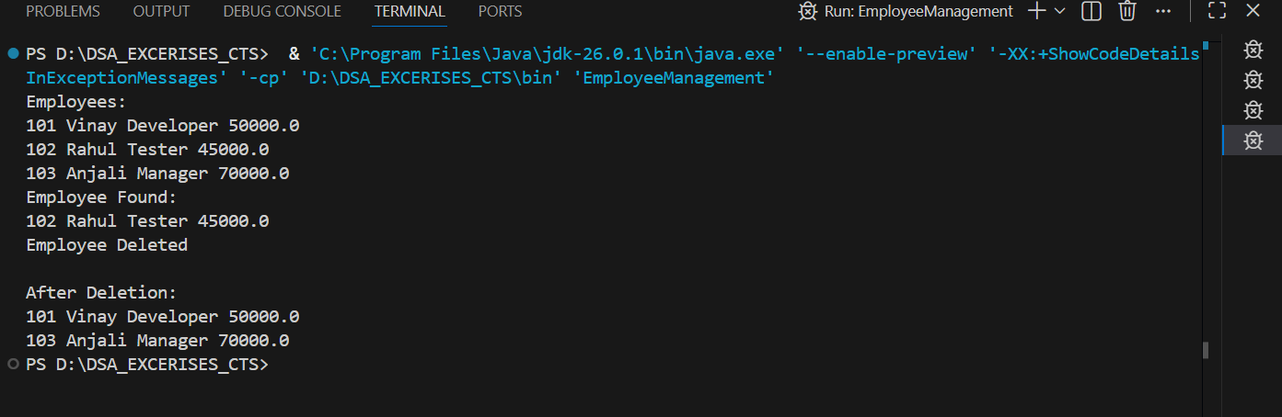

Ex-5: Task Management System
1. Explain the different types of linked lists.
Singly Linked List:
Each node contains data and a pointer to the next node.
Doubly Linked List:
Each node contains data, a pointer to the next node, and a pointer to the previous node.
Implementation:
Task.java:
public class Task {

int taskId;
String taskName;
String status;
Task next;

Task(int taskId, String taskName, String status) {
this.taskId = taskId;
this.taskName = taskName;
this.status = status;
this.next = null;
}
}
TaskManagement.java:
public class TaskManagement {

Task head = null;

// Add Task
public void addTask(int id, String name, String status) {

Task newTask = new Task(id, name, status);

if (head == null) {
head = newTask;
} else {

Task temp = head;

while (temp.next != null) {
temp = temp.next;
}

temp.next = newTask;
}

System.out.println("Task Added");
}

// Search Task
public void searchTask(int id) {

Task temp = head;

while (temp != null) {

if (temp.taskId == id) {

System.out.println("Task Found");
System.out.println(temp.taskId + " " + temp.taskName + " " + temp.status);
return;
}

temp = temp.next;
}

System.out.println("Task Not Found");
}

// Display Tasks
public void displayTasks() {

Task temp = head;

while (temp != null) {

System.out.println(temp.taskId + " " + temp.taskName + " " + temp.status);

temp = temp.next;
}
}

// Delete Task
public void deleteTask(int id) {

if (head == null)
return;

if (head.taskId == id) {

head = head.next;
System.out.println("Task Deleted");
return;
}

Task temp = head;

while (temp.next != null && temp.next.taskId != id) {
temp = temp.next;
}

if (temp.next != null) {
temp.next = temp.next.next;
System.out.println("Task Deleted");
} else {
System.out.println("Task Not Found");
}
}

public static void main(String[] args) {

TaskManagement obj = new TaskManagement();

obj.addTask(101, "Design UI", "Pending");
obj.addTask(102, "Write Code", "In Progress");
obj.addTask(103, "Testing", "Pending");

System.out.println("\nTasks:");

obj.displayTasks();

obj.searchTask(102);

obj.deleteTask(102);

System.out.println("\nAfter Deletion:");

obj.displayTasks();
}
}
Output:
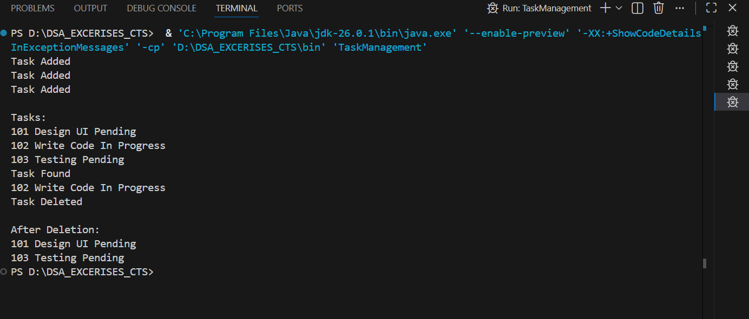

Ex-6: Library Management System
1. Explain Linear Search:
Linear Search checks each element one by one until the required element is found.
2. Explain Binary Search:
Binary Search repeatedly divides a sorted array into halves until the required element is found.

Implementation:
Book.java:
public class Book {

int bookId;
String title;
String author;

Book(int bookId, String title, String author) {
this.bookId = bookId;
this.title = title;
this.author = author;
}

@Override
public String toString() {
return bookId + " " + title + " " + author;
}
}
LibraryManagement.java:
public class LibraryManagement {

// Linear Search
public static Book linearSearch(Book[] books, String title) {

for (Book b : books) {
if (b.title.equalsIgnoreCase(title)) {
return b;
}
}

return null;
}

// Binary Search
public static Book binarySearch(Book[] books, String title) {

int low = 0;
int high = books.length - 1;

while (low <= high) {

int mid = (low + high) / 2;

int result = books[mid].title.compareToIgnoreCase(title);

if (result == 0)
return books[mid];
else if (result < 0)
low = mid + 1;
else
high = mid - 1;
}

return null;
}

public static void main(String[] args) {

// Keep books sorted by title for Binary Search
Book[] books = {

new Book(104,"C Programming","Dennis"),
new Book(101,"Data Structures","Mark"),
new Book(102,"Java","James"),
new Book(103,"Python","Guido")
};

Book b1 = linearSearch(books, "Java");

if (b1 != null)
System.out.println("Linear Search : " + b1);
else
System.out.println("Book Not Found");

Book b2 = binarySearch(books, "Java");

if (b2 != null)
System.out.println("Binary Search : " + b2);
else
System.out.println("Book Not Found");
}
}
Output:
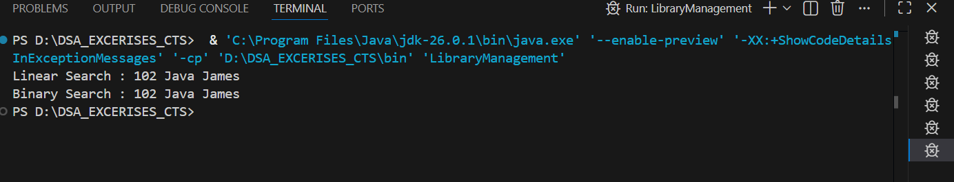

Ex-7: Financial Forecasting
1. Explain the concept of recursion:
Recursion is a technique where a method calls itself until a base condition is reached.
Implementation:
FinancialForecast.java:
public class FinancialForecast {

// Recursive method
public static double futureValue(double amount, double rate, int years) {

if (years == 0)
return amount;

return futureValue(amount * (1 + rate), rate, years - 1);
}

public static void main(String[] args) {

double amount = 10000;
double rate = 0.10; // 10%
int years = 5;

double result = futureValue(amount, rate, years);

System.out.println("Future Value = " + result);
}
}
Output:
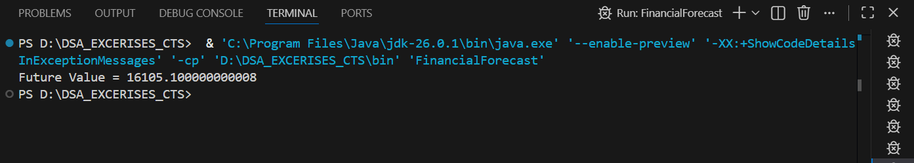
Analysis:
Time Complexity
O(n)
because the recursive method is called once for each year.
How can it be optimized?
The recursive solution can be optimized using Dynamic Programming (Memoization) or by using an iterative approach to reduce function call overhead.

